

|  |
| --- |
|  |
| Add / Delete patients using the Open MRS Portal |
|  |

Overview

OpenMRS database is used for storing all the details for patients. Patient details can be added, updated or deleted in OpenMRS database with the help of a portal provided with OpenMRS.

OpenMRS is also deployed in localhost tomcat server. So to access OpenMRS, URL will be [**http://localhost:8080/openmrs/**](http://localhost:8080/openmrs/) .

In case it is hosted on cloud server, then URL needs to change and server IP will replace **localhost** where applications are deployed.

OpenMRS homepage will have facility to login to the application. The default credential will be as follows

Username: admin; Password: admin

To add or delete a patient following steps need to be followed:

# Login to App

1. Login to the application



1. Home screen will be displayed. Click on Find/Create patients in top bar



# Adding a Patient

1. On clicking following page will open. In second section for Create patients, enter the required details like Person name, DOB and gender and click on create Person.

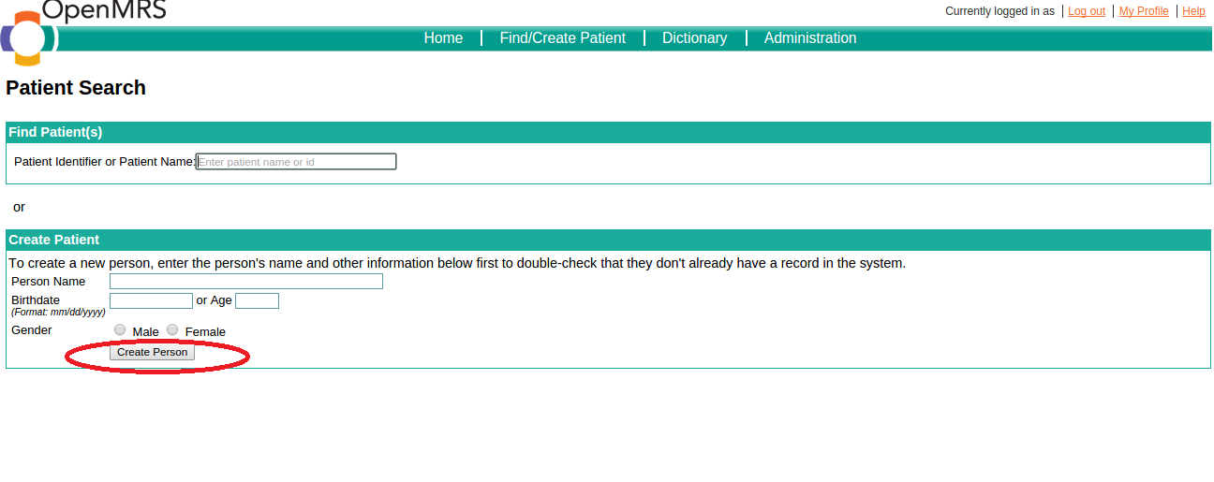

1. Following page will display. Enter further details about patient like complete name, identifier (need to add an identifier and assign a value), gender, age, address and click Save.

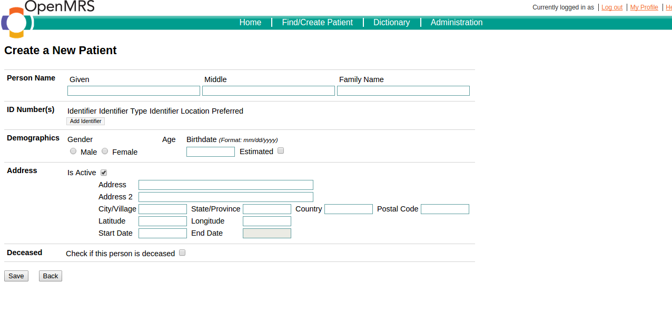

1. Patient will be created and saved. Click on Demographics below to verify details and edit if required. Also custom field like phone number will be added from here.

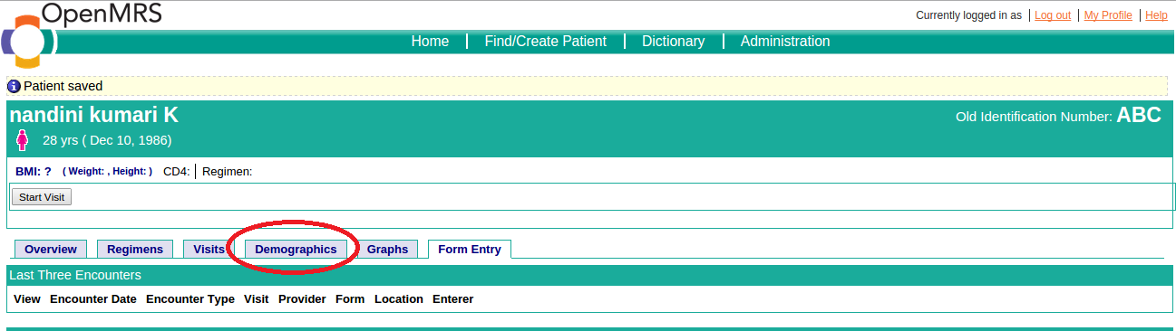

1. Click on edit patients to go to view update screen.

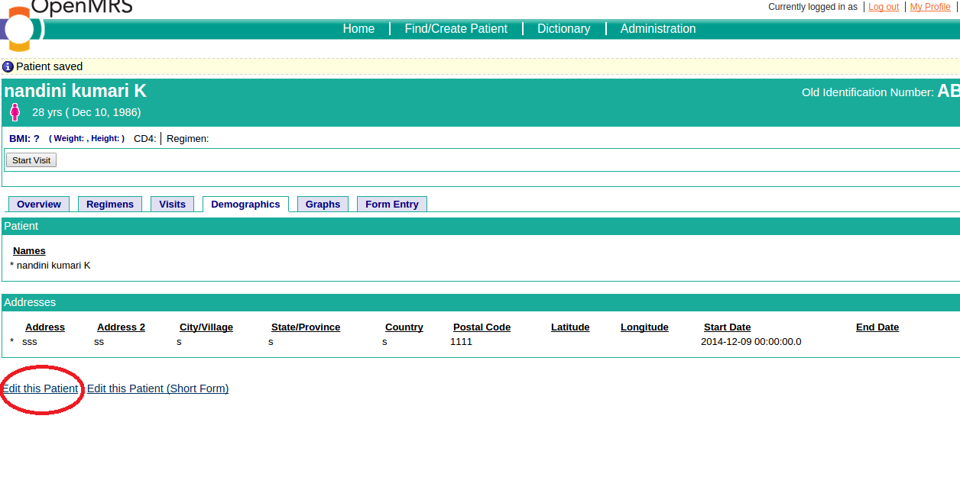

1. Update screen will open. In lower section, **in patient information add phone number also**. Click on save patient button.

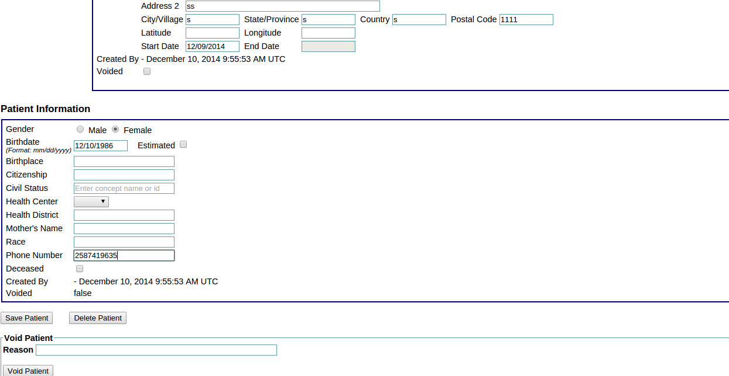

1. Patient details will be saved.

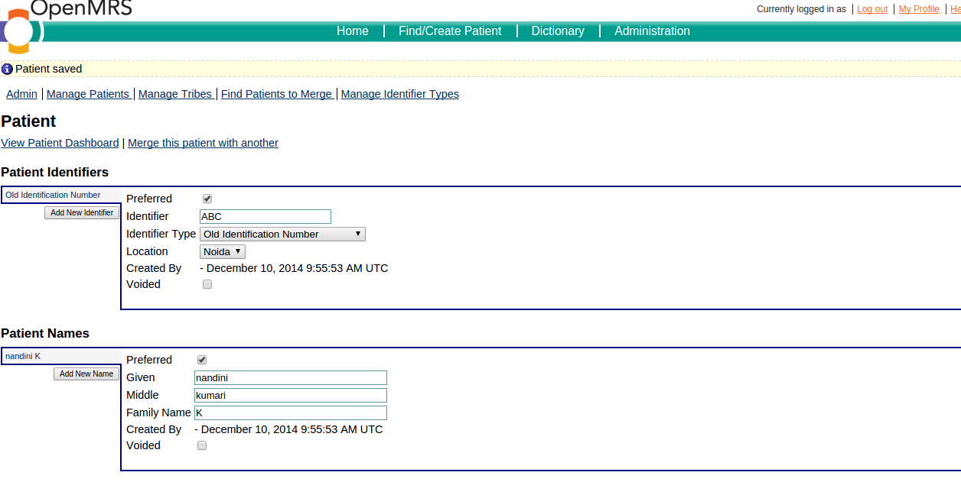

# Delete a patient

1. To delete a patient, go to the Administration option in top menu. Click on manage patients.

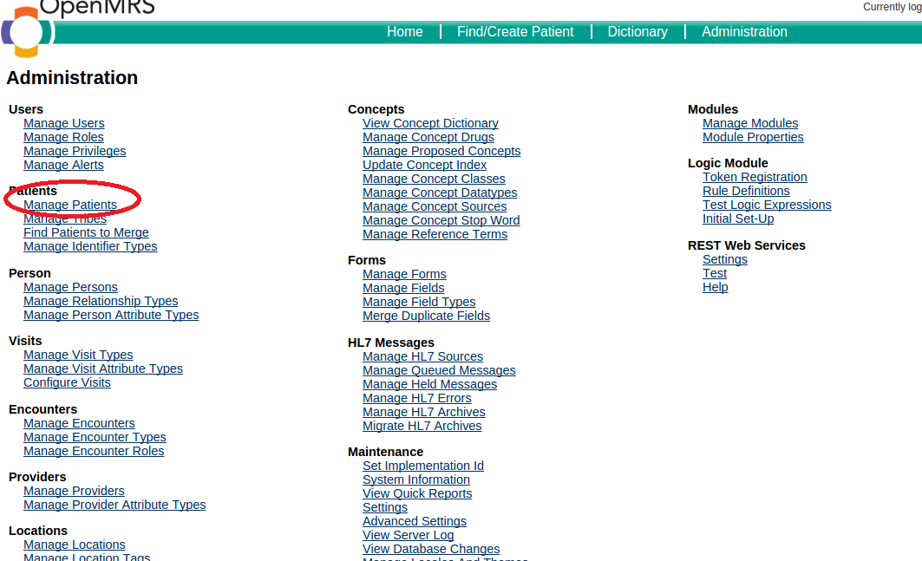

1. Search for the patient using name and click on the result row displayed.

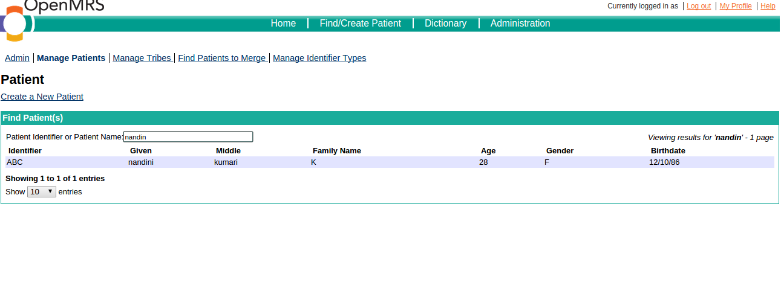

1. Detailed record of the patient will be displayed.

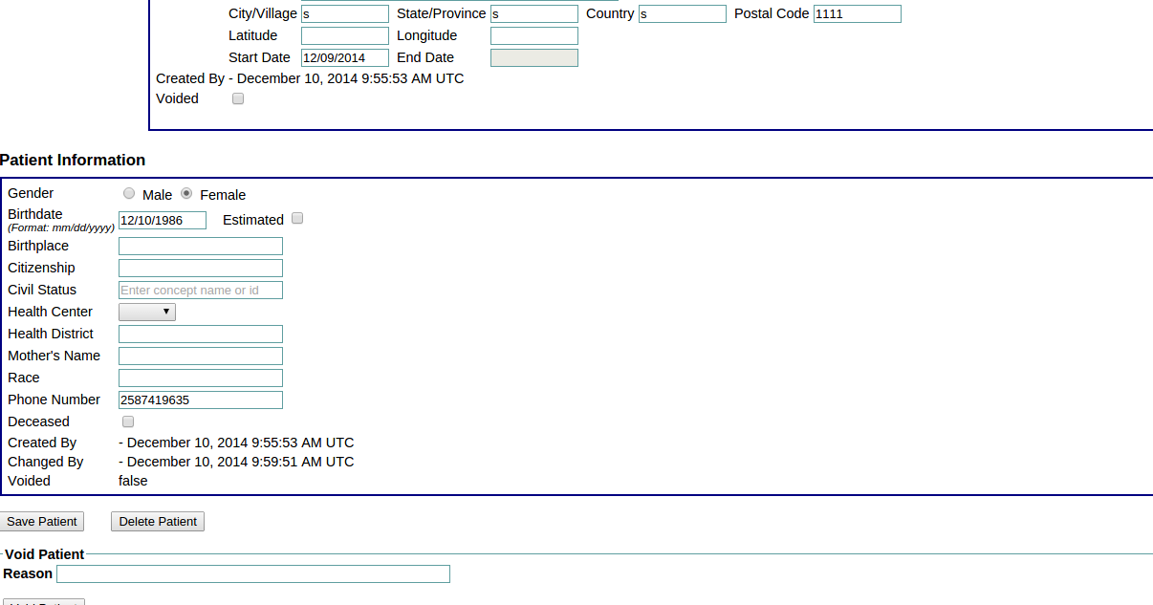

1. Click on Delete patient at the bottom of the screen.

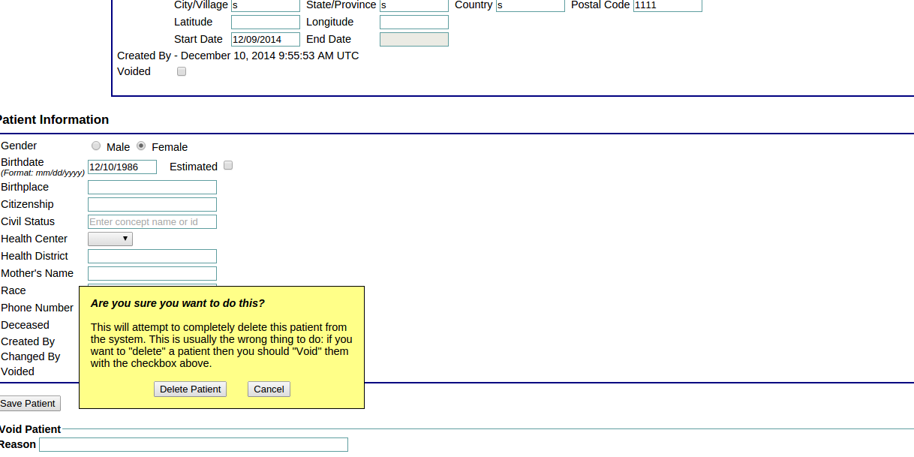

1. The patient will then be deleted.

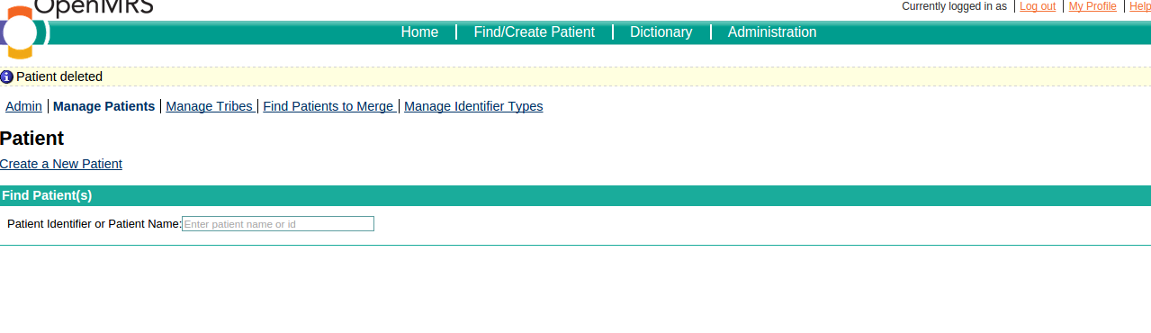

# ~~ End of Document ~~